Dear International Friend,  Thank you for your interest in our End of the SUMMER CAMP which will be held in Novara from 26 to 30 August at our school IPS Ravizza. Please mark that:  - your arrival should possibly be either on Sat 24th or Sun 25th  - departure on Sat 31st or Sun 1st Sept | 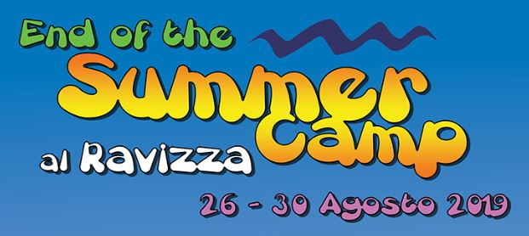
In order to register you we need to collect the following information:

Your name and surname
MALE/FEMALE
Languages spoken
Date/Place of birth
Nationality
Email
FB / Social Media contact
Mobile phone
Passport/ID number
PP/ID expiry date
Health Card number
Allergies/ Medicines / Diet(s)
Smoker (YES/NO)
Family habits
Pets (like/don’t like)
Hobbies/Sports
Other info

Please do not buy your flight ticket until you received official confirmation from us ☺
Thank you,
the RAVIZZA SUMMER CAMP TEAM

